“Rushmoor Christmas Angels” July 2020 Newsletter.

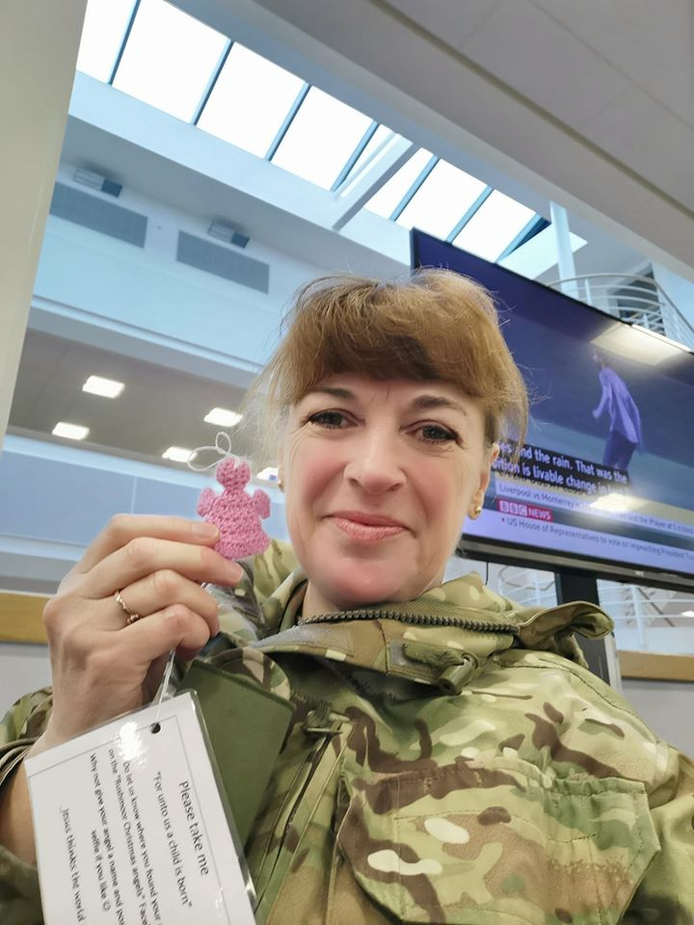
Hello everyone, and hello July…….we are now over half way through the year and dare we say it beginning the countdown to Christmas and “Rushmoor Christmas Angels” 2020”

Do look out for the (very) small article in the Rushmoor’s July “Arena” magazine featuring our NHS Angels.

The weeks ahead are still very uncertain but we hope that it is not too long until we are able to all meet together again and have a knit and natter.

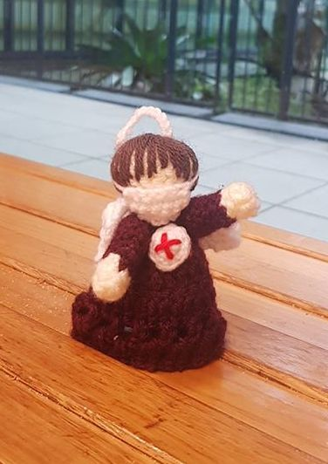
We are keeping a close eye on the various restrictions as they are lifted as well as the advice given to us by the government and looking at how all of this might impact our project. Keeping positive we are very much hoping that we will be able to meet in some form or another for the 3 planned “knitting parties” in the autumn term…..these are still planned for Sat 12th Sept (see paragraph below), Sat 10th Oct and Sat 21st Nov. We are also still planning to have our “Rushmoor Christmas Angels” dedication service on Thursday 3rd December. Angels will start to be placed around Rushmoor from Monday 7th December.

Sat 12th Sept is still the revised date for Aldershot Victoria day and we are keeping in close touch with the town centre management team regarding our participation in this event……all we can say at the moment is watch this space regarding Victoria Day and our knitting parties.

We estimate that we produced well over 1,000 NHS and Keyworker angels during the past few months and it has been amazing to see how far some of our NHS and Keyworker angels have travelled as people post their pictures on our social media platforms. The Angel to the right “flew” all the way to New Zealand which we believe is the furthest any of our angels has ever travelled.
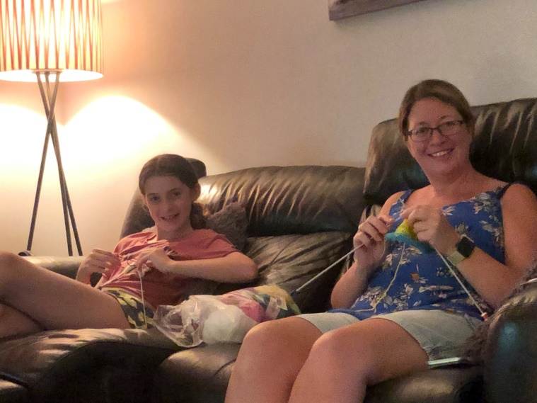
We love seeing all the pictures that get posted on both our Facebook pages so please keep them coming. We were especially thrilled when we saw how “Rushmoor Christmas Angels” was developing into a “family thing”. Jane and Rebecca (in the picture on the left) both leant to knit during lockdown and have so far made 50 angels between them……amazing effort. We are sure that their angels will be very much appreciated around Rushmoor this coming Christmas.

I have a couple of laundry bags full of donated wool. If anyone needs wool please let me know and I will get some to you.

David Betts,7 Redvers Buller Road, Aldershot, GU11 2LT. dabetts4x4@btinternet.com 01252 328959 or 07941 997841 or 07747 216735

