“Rushmoor Christmas Angels” June 2021 Newsletter.

Hello everyone
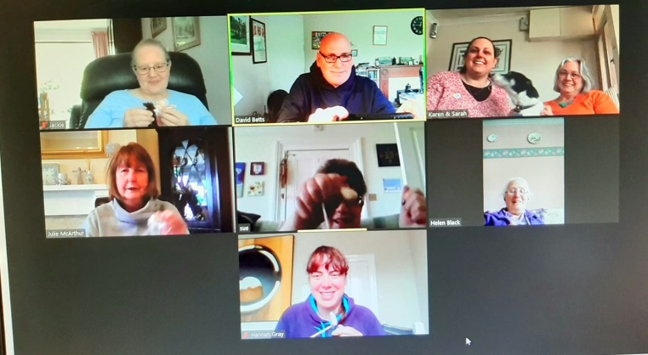
I guess that as we are now in June we can truthfully say that we are “counting down” to Christmas.

As strange and unbelievable as it may sound, in six months’ time we will be getting ready to launch Rushmoor Christmas angels 2021…..our 7th year. I am sure that our angels will be just as sought after and just as meaningful this coming year as they were at the end of 2020

It can be difficult to think of Christmassy things to write in a June newsletter when the sun is shining…..and we have just enjoyed a lovely Bank Holiday…..but “think” I must .

During our last Zoom gathering we were wondering whether as well as distributing our angels around our community we could also maybe focus on an organisation or establishment.

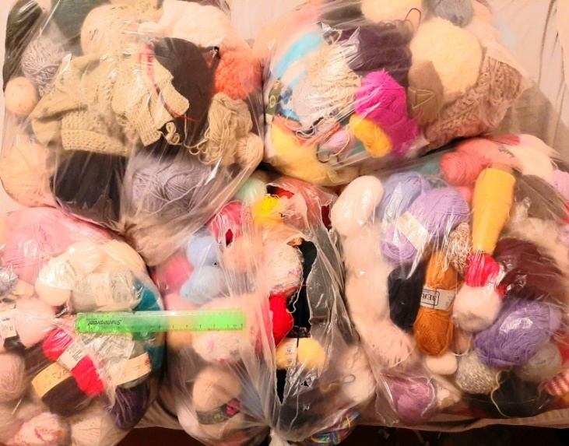
We did think whether could get enough angels together to give everyone who works at Aldershot Town football club an angel. But we may have bitten off more than we can chew with this particular suggestion so we are open to any other ideas you may have. Maybe a care home or a school? If this works we could choose a different group or organisation to focus on the following year.

This idea is still very much in its early stages of being worked through and nothing as yet is set in stone so please do feel free to share any ideas you may have. In all reality we don’t need to decide until the very last minute.

Our next gathering on Zoom will be on Saturday June 19th. Watch out for details a little nearer the time. Depending on what restrictions are lifted in mid-June we are hoping that we will be able to meet in person sometime in July.

We have loads of labels for those of you who find it easier to “label as you go” and we have loads of wool too so please do let me know if you need either labels or wool. We can easily arrange a time for you to pick it up or for it to be dropped off.

If you are the point of contact for a knitter, knitting group or church could you please do your best to forward this newsletter on to members of your team. This is especially important if some of your team are not on social media/email etc. This newsletter is often their only means of finding out information about our project. I can always get you hard copies of this newsletter if this would help.
Once again a massive thank you to all of you for all that you do to make this project what it is.

David Betts, 7 Redvers Buller Road, Aldershot, GU11 2LT. dabetts4x4@btinternet.com 01252 328959 or 07941 997841

