“Rushmoor Christmas Angels” February 2022 Newsletter.

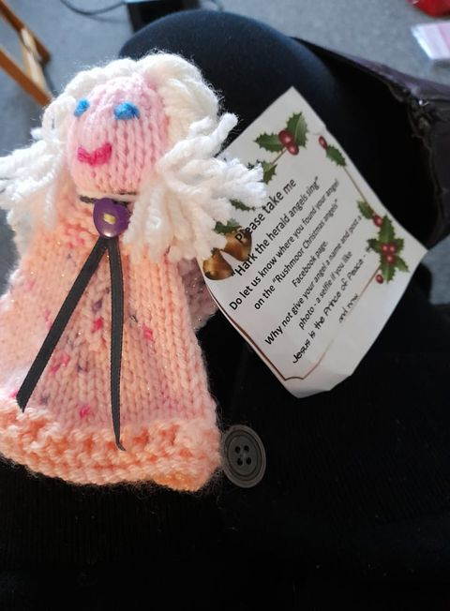
Hello everyone and a very big welcome to you if you are new to the “team” and this is your first “Rushmoor Christmas Angels” newsletter.

There is a Facebook group for the “Rushmoor Christmas Angels” team members that you may wish to join. Look up “RCA knitters”. This is a platform where we share a lot of our news.
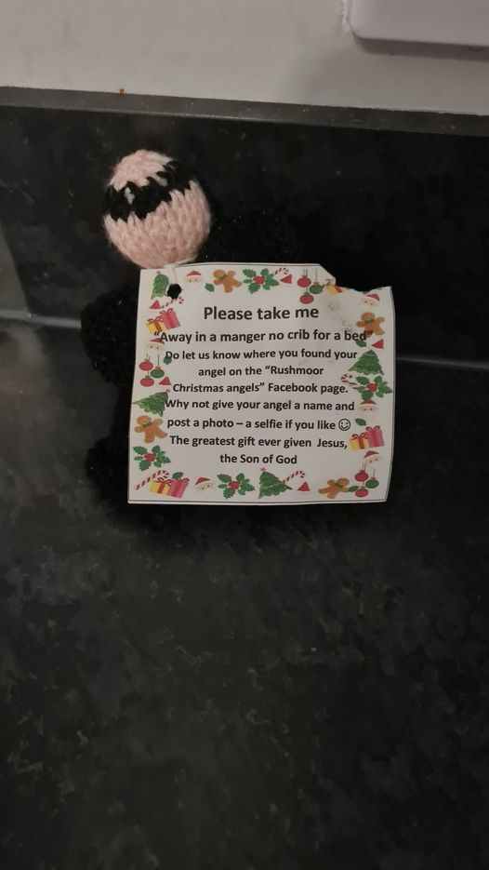
I mentioned in the last newsletter that there are often a few angels found well into the New Year and true to form a few days after the newsletters were sent out someone posted on the Facebook page that they had just found an angel in Shilon, County Durham, see below. However, I do recall a few years ago one angel was found in April so there is a long way to go to beat that particular record.
It was lovely to see everyone a few weeks ago at our first Knitting Party of the New Year. It sounds as if we may well already have near on 1000 angels knitted for “Rushmoor Christmas Angels” 2022
Our next knitting party will be on Saturday 19th Feb. This will be a “Taster” session for those people who may wish to “have a go” at knitting or crocheting an angel and get a little bit of help and advice from those who have been knitting for a while. **It might be worth having a few spare pairs of needles and some extra crochet hooks available. I can always copy extra knitting patterns.

Sometimes our “distributers” are determined to one day join the ranks of our “knitters”. A week or so ago I received the picture below. After a number of years distributing other people’s angels Elaine has knitted her very first angel and can now finally have the joy of placing an angel of her own making this coming Christmas. Well done Elaine!!! PS Elaine is now up to at least 5 knitted angels
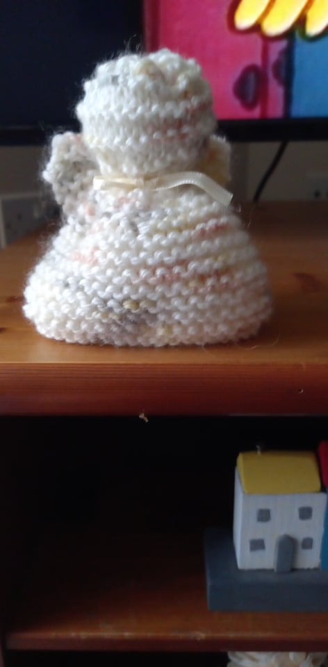
420 newsletters are sent out each month and at the time of typing this newsletter 532 people are now members of the RCA FB group….. and who really knows how many angels are produced each year? I know that there is some overlap with the first two figures above, but isn’t it amazing how our project has grown over the past years.

If you are the point of contact for a knitter, knitting group or church could you please do your best to forward this newsletter on to members of your team. I can always get you hard copies of this newsletter if this would help.

Once again a massive thank you to ALL of you for all that you do to make this project what it is. I look forward to seeing you on the 19th February.

David Betts, 7 Redvers Buller Road, Aldershot, GU11 2LT. dabetts4x4@btinternet.com 01252 328959 or 07941 997841

