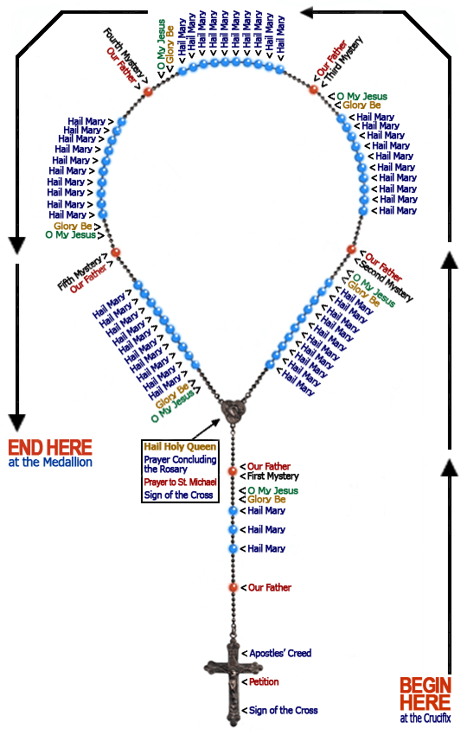

How to Pray the Rosary

- Begin by holding the crucifix, saying "In the Name of the Father and of the Son and of the Holy Spirit," (making the sign of the Cross while doing that), then say the Apostles’ Creed.
- On the single bead just above the cross, pray the "Our Father." This and all prayers of the rosary are meditative prayers.
- The next cluster has 3 beads. The "Hail Mary" prayer is said on these three beads. You pray the 3 Hail Marys while meditating on the three divine virtues of faith, hope, and love/charity.

- On the chain or cord after the three beads, say the "Glory be to the Father ..."
- On the next bead, which is a single bead, you announce the first divine mystery of contemplation. For example, if it were a Monday, you would say the first Joyful Mystery is "The Annunciation", at this point you pray the "Our Father" prayer.
- Now this will bring you to the first decade, or set of 10 beads of the Rosary. You will then pray 10 Hail Marys while contemplating the first mystery, for example: The Annunciation.
- After the 10th Hail Mary you will have completed the first of 5 decades which make up a Chaplet of the Rosary. You now come to another single bead, at this point, you pray the Glory be to the Father... then (on the same bead) pray the O My Jesus ... then (on the same bead) announce the next or second mystery. For example: if it’s Monday and you’re praying the Joyful Mysteries, the second Joyful Mystery is The Visitation. At this point you pray the Our Father....
- You will now come to the second decade or group of 10 beads, you will now pray the 10 Hail Marys while contemplating the appropriate mystery.
- You continue to pray the rosary the same way throughout. If your intention is to pray a Chaplet (a single set of mysteries) at the end of the fifth mystery you will come back to the joiner, this is where the decades all join with the lower part of the rosary which contains the cross. When you come to the joiner, you decide whether or not you wish to say another Chaplet or end. If you decide to say another Chaplet you simply announce the next mystery and continue. If you wish to end, you simply say the Glory be to the Father, the O My Jesus, the Our Father and end the rosary with the Hail Holy Queen and the sign of the Cross........

Various Rosary Prayers in approximate order as prayed in the Rosary

THE APOSTLE'S CREED

I believe in God, the Father Almighty, Creator of heaven and earth and in Jesus Christ, His only Son, our Lord; Who was conceived by the Holy Spirit, born of the Virgin Mary, suffered under Pontius Pilate, was crucified, died, and was buried, He descended into hell; the third day He arose again from the dead; He ascended into Heaven, sitteth at the right hand of God, the Father Almighty, from thence He shall come to judge the living and the dead. I believe in the Holy Spirit, the Holy Catholic Church, the communion of saints, the forgiveness of sins, the resurrection of the body, and life everlasting. Amen.

THE OUR FATHER

Our Father, Who art in Heaven, hallowed be Thy name; Thy Kingdom come, Thy will be done on earth as it is in Heaven. Give us this day our daily bread; and forgive us our trespasses as we forgive those who trespass against us; and lead us not into temptation, but deliver us from evil. Amen.

THE DOXOLOGY

Glory be to the Father, the Son, and the Holy Spirit. As it was in the beginning is now and ever shall be, world without end. Amen. (this prayer is optional and may be said after all Glory Be to the Fathers.....)
O my Jesus, have mercy on us. Forgive us our sins. Save us from the fires of hell. Take all souls into heaven, especially, those most in need of thy mercy. Amen.

THE HAIL MARY

Hail Mary, full of grace, the Lord is with thee, blessed art thou amongst women and blessed is the fruit of thy womb, Jesus. Holy Mary Mother of God, pray for us sinners now and at the hour of our death. Amen.

DECADE PRAYER (Prayer for Priests)

God, our Father, please send us holy priests, all for the sacred and eucharistic heart of Jesus, all for the sorrowful and immaculate heart of Mary, in union with saint Joseph. Amen.

THE SALVE REGINA (Hail Holy Queen)

Hail Holy Queen, Mother of Mercy, our life our sweetness and our hope. To thee do we cry, poor banished children of Eve; To thee do we send up our sighs, mourning and weeping in this valley of tears. Turn then, most gracious advocate, thine eyes of mercy toward us and after this our exile show unto us the blessed fruit of thy womb, Jesus. O clement, O loving, O sweet Virgin Mary!
V: Pray for us, O Holy Mother of God
R: That we may be made worthy of the promises of Christ.

LET US PRAY

O God, whose only begotten Son, by His life, death, and resurrection, has purchased for us the rewards of eternal salvation. Grant, we beseech Thee, that while meditating on these mysteries of the most holy Rosary of the Blessed Virgin Mary, that we may imitate what they contain and obtain what they promise, through Christ our Lord. Amen.
Most Sacred Heart of Jesus, have mercy on us.
Immaculate Heart of Mary, pray for us.

FATIMA PRAYER

Most Holy Trinity - Father, Son, and Holy Spirit - I adore thee profoundly. I offer Thee the most precious Body, Blood, Soul and Divinity of Jesus Christ, present in all the tabernacles of the world, in reparation for the outrages, sacrileges and indifference's whereby He is offended. And through the infinite merits of His Most Sacred Heart and the Immaculate Heart of Mary, I beg of Thee the conversion of poor sinners.

"Let this prayer be echoed all over the world." - Mary

Fatima Prayer

My God, I believe, I adore, I hope, and I love You. I beg pardon of You for those who do not believe, do not adore, do not hope, and do not love You.
Mary, Queen of the Holy Rosary, pray for us. Mary, Queen of Peace, pray for us. Mary, Our Loving Mother, pray for us.

MEMORARE

Remember, O most gracious Virgin Mary that never was it known that anyone who fled to Your protection, implored Your help, or sought Your intercession was left unaided. Inspired with this confidence, we fly to you, O Virgin of virgins, our Mother. To You we come; before You we stand, sinful and sorrowful. O Mother of the Word Incarnate, despise not our petitions, but in Your mercy, hear and answer us. Amen.

