Bishop Paul McAleenan, Lead Bishop for Racial Justice, sends this message …
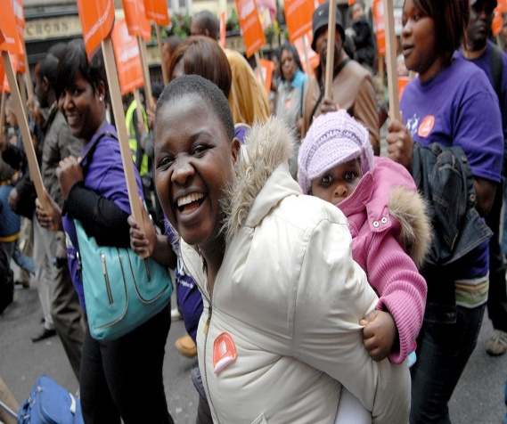
Ethnic minorities have suffered disproportionately from the COVID-19 pandemic, demonstrating a systemic problem with racial injustice in our society.
This was dramatically brought home with the brutal killing of George Floyd and the reaction it provoked. As Pope Francis reflects: “instances of racism continue to shame us, for they show that our supposed social progress is not as real or definitive as we think.”

Dismantle structures of injustice
These shameful reminders of racism demand meaningful action to confront and dismantle sinful structures of injustice. Our brother Bishops in the USA remind us that: “all of us are in need of personal, ongoing conversion. Our churches and our civic and social institutions are in need of ongoing reform. If racism is confronted by addressing its causes and the injustice it produces, then healing can occur.”
Racism is a sin and a violation of human dignity in which we are all complicit. As Catholics we need to acknowledge and confront our own failings, as individuals and as a Church.
Every single one of our parishes, schools and organisations has a responsibility to actively practise anti-racism in all aspects of our mission.
We need to address the lack of visible diversity at every level, so that people can see themselves, their race, their culture and their history in the Church’s life.
We need to engage suppliers and businesses from all parts of the community, seeking out those which promote diversity and inclusivity.
Most importantly we need to actively invite people from different ethnic communities to share their experiences and genuinely listen to their voices, however challenging this may be.

A Time to Act
It is not enough to simply denounce racism. This is a time to act. In the words of the Holy Father: “This is a moment to dream big, to rethink our priorities — what we value, what we want, what we seek — and to commit to act in our daily life on what we have dreamed of. God asks us to dare to create something new.”
Bishop Paul McAleenan
Lead Bishop for Racial Justice

