“Rushmoor Christmas Angels” October 2020 Newsletter.

Hello everyone
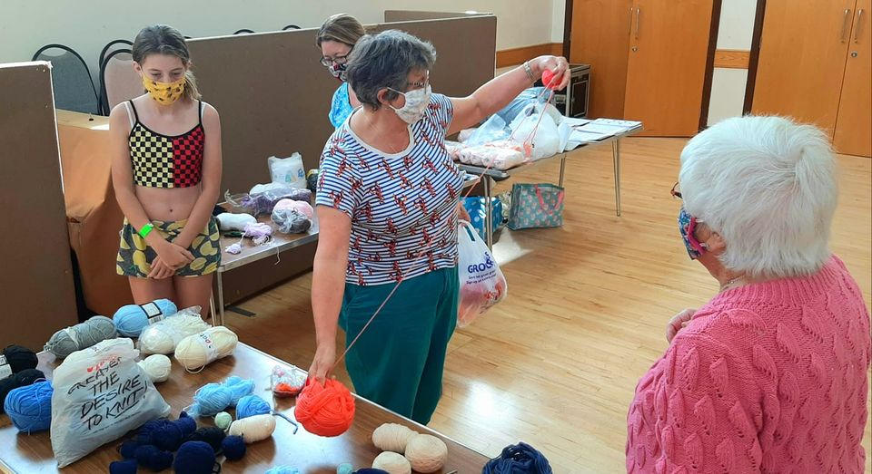
As usual we want to say welcome to those “knitters” who have joined us since the last newsletter was sent out. Those who follow our knitting group on Facebook may well have seen that we are fast approaching 400 knitters.

It was lovely to see those of you who were able to come along to North Camp Methodist Church to pick up some labels and wool a few weeks ago. Although it wasn’t the kind of session we really would have wanted it was nice to have a few moments together to chat about all things “knitting”.

Obviously our project is going to look much different this year, especially in the build-up and as a result of this will take a little bit more coordinating. We had planned to hold a “knitting Party” on Saturday Oct 10th and Saturday Nov 14th. These will now be “drop off and pick up sessions”.

If you have Angels already knitted but have not as yet been “labelled” do try to come along on one of the Saturdays and pick up some labels. I still have some donated wool and will have that available on these Saturdays as well. Please note that this will just be a socially distanced “drop off and pick up session” and the usual Covid19 guidelines will need to be adhered to (track and trace, hand sanitiser, face masks etc). However, if you can come along even if it is just for 15mins it will be good to see you.

Whatever way it works we need to make sure that all are Angels are labelled, with our distributers and ready to fly by December 7th

We are still planning to have our “Rushmoor Christmas Angels” dedication service on Thursday 3rd December (At the moment this will take place “virtually” and we are looking at the best way to do this….. Watch this space.
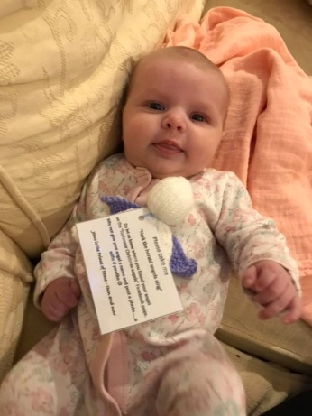
We have asked many questions and had many replies regarding how best to distribute our angels in the midst of COVID-19 and it would seem that the general consensus is that if when we distribute our knitted angels we take all necessary precautions (hand sanitiser, face masks etc) there is no reason why our project should not go ahead as usual this Christmas.

We are aware that we did say that we were trying to cut down on the amount of plastic we were using hence not laminating our labels, but it might just be that for this year we have to place our angels in small plastic bags which will keep the angel “isolated” until it is found. I have ordered some bags to test size etc. and will inform you all via the FB group how this works out. Obviously those families who find any “un bagged” angels can keep them “quarantined” in other wats before placing them into their homes and we will put something on the Facebook page to that effect nearer the time.

If you are the point of contact for a knitting group or church could you please pass this newsletter onto members of your team and if possible print off and display this on your church noticeboard

David Betts, 7 Redvers Buller Road, Aldershot, GU11 2LT. dabetts4x4@btinternet.com 01252 328959 or 07941 997841 or 07747 216735

