Message of His Holiness Pope Francis for the 106th World Day of Migrants and Refugees 2020

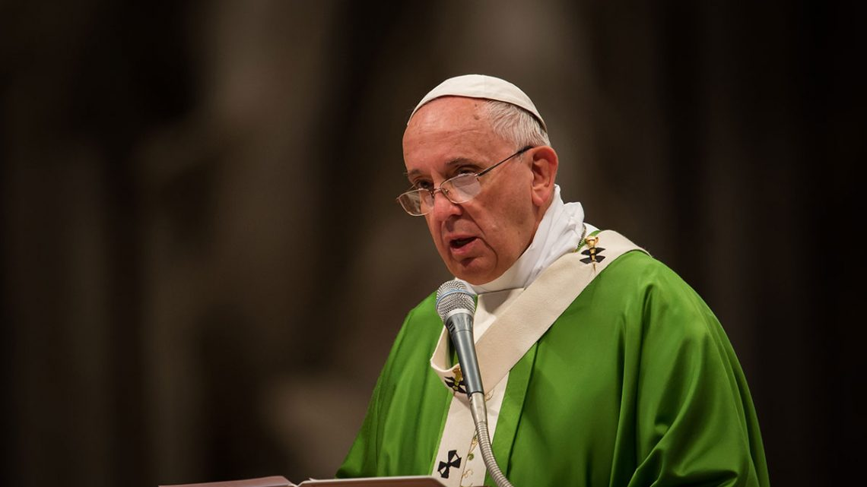
Like Jesus Christ, forced to flee.
Welcoming, protecting, promoting and integrating
internally displaced persons
At the beginning of this year, in my Address to the members of the Diplomatic Corps accredited to the Holy See, I pointed to the tragedy of internally displaced people as one of the challenges of our contemporary world: “Situations of conflict and humanitarian emergencies, aggravated by climate change, are increasing the numbers of displaced persons and affecting people already living in a state of dire poverty. Many of the countries experiencing these situations lack adequate structures for meeting the needs of the displaced” (9 January 2020).
The Migrants and Refugees Section of the Dicastery for Promoting Integral Human Development has issued the document “Pastoral Orientations on Internally Displaced People” (Vatican City, 5 May 2020), which aims to inspire and encourage the pastoral work of the Church in this specific area.
For these reasons, I have decided to devote this Message to the drama of internally displaced persons, an often unseen tragedy that the global crisis caused by the COVID-19 pandemic has only exacerbated. In fact, due to its virulence, severity and geographical extent, this crisis has impacted on many other humanitarian emergencies that affect millions of people, which has relegated to the bottom of national political agendas those urgent international efforts essential to saving lives. But “this is not a time for forgetfulness. The crisis we are facing should not make us forget the many other crises that bring suffering to so many people” (Urbi et Orbi Message, 12 April 2020).
In the light of the tragic events that have marked 2020, I would like this Message, although concerned with internally displaced persons, to embrace all those who are experiencing situations of precariousness, abandonment, marginalization and rejection as a result of COVID-19.
I would like to start with the image that inspired Pope Pius XII in his Apostolic Constitution Exsul Familia (1 August 1952). During the flight into Egypt, the child Jesus experienced with his parents the tragic fate of the displaced and refugees, “which is marked by fear, uncertainty and unease (cf. Mt 2:13-15, 19-23). Unfortunately, in our own times, millions of families can identify with this sad reality. Almost every day the television and papers carry news of refugees fleeing from hunger, war and other grave dangers, in search of security and a dignified life for themselves and for their families” (Angelus, 29 December 2013). In each of these people, forced to flee to safety, Jesus is present as he was at the time of Herod. In the faces of the hungry, the thirsty, the naked, the sick, strangers and prisoners, we are called to see the face of Christ who pleads with us to help (cf. Mt 25:31-46). If we can recognize him in those faces, we will be the ones to thank him for having been able to meet, love and serve him in them.
Displaced people offer us this opportunity to meet the Lord, “even though our eyes find it hard to recognize him: his clothing in tatters, his feet dirty, his face disfigured, his body wounded, his tongue unable to speak our language” (Homily, 15 February 2019). We are called to respond to this pastoral challenge with the four verbs I indicated in my Message for this Day in 2018: welcome, protect, promote and integrate. To these words, I would now like to add another six pairs of verbs that deal with very practical actions and are linked together in a relationship of cause and effect.
You have to know in order to understand. Knowledge is a necessary step towards understanding others. Jesus himself tells us this in the account of the disciples on the road to Emmaus: “While they were talking and discussing together, Jesus himself drew near and went with them, but their eyes were kept from recognizing him” (Lk 24:15-16). When we talk about migrants and displaced persons, all too often we stop at statistics. But it is not about statistics, it is about real people! If we encounter them, we will get to know more about them. And knowing their stories, we will be able to understand them. We will be able to understand, for example, that the precariousness that we have come to experience as a result of this pandemic is a constant in the lives of displaced people.
It is necessary to be close in order to serve. It may seem obvious, yet often it is the contrary. “But a Samaritan, as he journeyed, came to where the man was; and when he saw him, he had compassion, and went to him and bound up his wounds, pouring on oil and wine; then he set him on his own beast and brought him to an inn, and took care of him” (Lk 10:33-34). Fears and prejudices – all too many prejudices – keep us distant from others and often prevent us from “becoming neighbours” to them and serving them with love. Drawing close to others often means being willing to take risks, as so many doctors and nurses have taught us in recent months. This readiness to draw near and serve goes beyond a mere sense of duty. Jesus gave us the greatest example of this when he washed the feet of his disciples: he took off his cloak, knelt down and dirtied his hands (cf. Jn 13:1-15).
In order to be reconciled, we need to listen. God himself taught us this by sending his Son into the world. He wanted to listen to the plea of suffering humanity with human ears: “For God so loved the world that he gave his only-begotten Son… that the world might be saved through him” (Jn 3:16-17). A love that reconciles and saves begins with listening. In today’s world, messages multiply but the practice of listening is being lost. Yet it is only through humble and attentive listening that we can truly be reconciled. In 2020, silence has reigned for weeks in our streets. A dramatic and troubling silence, but one that has given us the opportunity to listen to the plea of the vulnerable, the displaced and our seriously ill planet. Listening gives us an opportunity to be reconciled with our neighbour, with all those who have been “discarded”, with ourselves and with God, who never tires of offering us his mercy.
In order to grow, it is necessary to share. Sharing was an essential element of the first Christian community: “Now the company of those who believed were of one heart and soul, and no one said that any of the things which he possessed was his own, but they had everything in common” (Acts 4:32). God did not want the resources of our planet to benefit only a few. This was not the Lord’s will! We have to learn to share in order to grow together, leaving no one behind. The pandemic has reminded us how we are all in the same boat. Realizing that we have the same concerns and fears has shown us once more that no one can be saved alone. To grow truly, we must grow together, sharing what we have, like the boy who offered Jesus five barley loaves and two fish… yet they proved enough for five thousand people (cf. Jn 6:1-15)!
We need to be involved in order to promote. As Jesus was with the Samaritan woman (cf. Jn 4:1- 30). The Lord approaches her, listens to her, speaks to her heart, and then leads her to the truth and makes her a herald of the Good News: “Come, see a man who told me all that I ever did! Can this be the Christ?” (v. 29). Sometimes the impulse to serve others prevents us from seeing their real riches. If we really want to promote those whom we assist, we must involve them and make them agents in their own redemption. The pandemic has reminded us of how essential coresponsibility is, and that only with the contribution of everyone – even of those groups so often underestimated – can we face this crisis. We must find “the courage to create spaces where everyone can recognize that they are called, and to allow new forms of hospitality, fraternity and solidarity” (Meditation in Saint Peter’s Square, 27 March 2020).
It is necessary to cooperate in order to build. That is what the Apostle Paul tells the community of Corinth: “I appeal to you, brethren, by the name of our Lord Jesus Christ, that all of you agree and that there be no dissensions among you, but that you be united in the same mind and the same judgement” (1 Cor 1:10). Building the Kingdom of God is a duty common to all Christians, and for this reason it is necessary that we learn to cooperate, without yielding to the temptation to jealousy, discord and division. In the present context it should be reiterated: “This is not a time for self-centredness, because the challenge we are facing is shared by all, without distinguishing between persons” (Urbi et Orbi Message, 12 April 2020). To preserve our common home and make it conform more and more to God’s original plan, we must commit ourselves to ensuring international cooperation, global solidarity and local commitment, leaving no one excluded.
I would like to conclude with a prayer suggested by the example of Saint Joseph at the time he was forced to flee to Egypt to save the child Jesus.
Father, you entrusted to Saint Joseph what you held most precious: the child Jesus and his Mother, in order to protect them from the dangers and threats of the wicked.
Grant that we may experience his protection and help. May he, who shared in the sufferings of those who flee from the hatred of the powerful, console and protect all our brothers and sisters driven by war, poverty and necessity to leave their homes and their lands to set out as refugees for safer places.
Help them, through the intercession of Saint Joseph, to find the strength to persevere, give them comfort in sorrows and courage amid their trials.
Grant to those who welcome them some of the tender love of this just and wise father, who loved Jesus as a true son and sustained Mary at every step of the way.
May he, who earned his bread by the work of his hands, watch over those who have seen everything in life taken away and obtain for them the dignity of a job and the serenity of a home.
We ask this through Jesus Christ, your Son, whom Saint Joseph saved by fleeing to Egypt, and trusting in the intercession of the Virgin Mary, whom he loved as a faithful husband in accordance with your will. Amen.

Given at Rome, Saint John Lateran, 13 May 2020, Memorial of the Blessed Virgin Mary of Fatima.

