“Rushmoor Christmas Angels” April 2022 Newsletter.

Hello everyone.
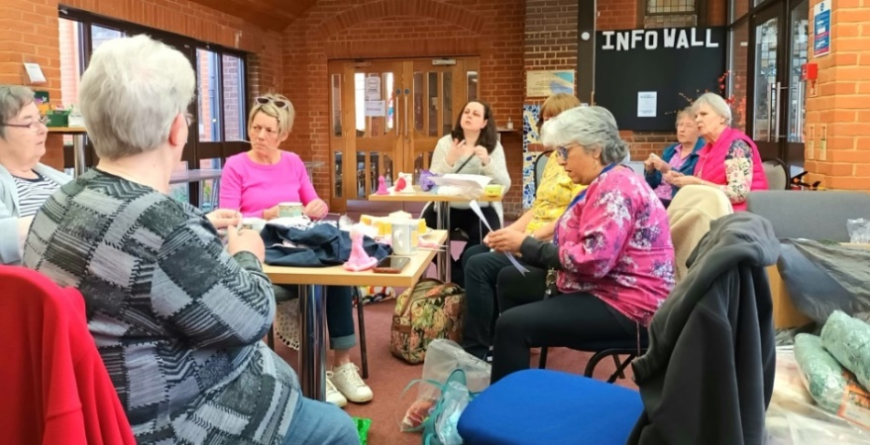
As always it was lovely to see you all at the last “knitting party”. Our next “knitting party” will be on Saturday 30th April at North Camp Methodist Church from 10am – 12 midday.

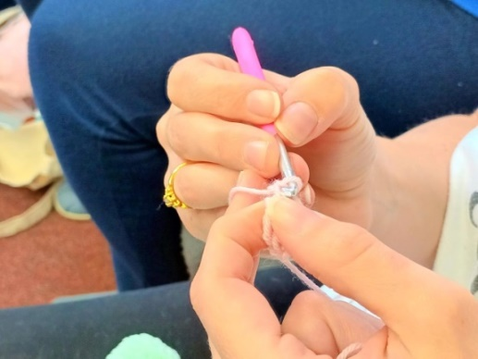
A few people have asked what the plan is once they have knitted their angels. Well, read on……..When we started knitted angels in 2015 we produced between 3000 and 4000. This amount could reasonably be stored in one place. However, over the years we have produced more and more angels as more and more knitters have joined the team. As a result it has become impossible to “keep” all the finished angels in one place. The plan therefore is for everyone, (if possible) to keep hold of the angels they knit until the “Angel dedication service” which we will hold on an evening during the week before we launch this year’s project in December 2022.

I heard recently how knitting can help a marriage last for a long time…. A man and a woman had been married for more than 60 years. They had kept no secrets from each other except that the old woman had a shoe box in the top of her wardrobe that she had cautioned her husband never to open or ask her about. For many years he never thought about the box, but one day she agreed that it was time he knew what was in the box. When he opened it, he found two knitted angels and a stack of money totalling £48,000. He asked his wife about the contents. “Before we were married,” she said, “my grandmother told me the secret of a happy marriage was to never argue. She told me that if I ever got angry with you, I should just keep quiet and knit an angel”. The old man was so moved; he had to fight back tears. Only two knitted angels were in the box. She had only been angry with him two times in all those years of living and loving. He almost burst with happiness. “Honey,” he said “that explains the angels, but what about all of this money? Where did it come from?” “Oh, that?” she said. “That’s the money I acquired from selling the other angels that I’ve made.”
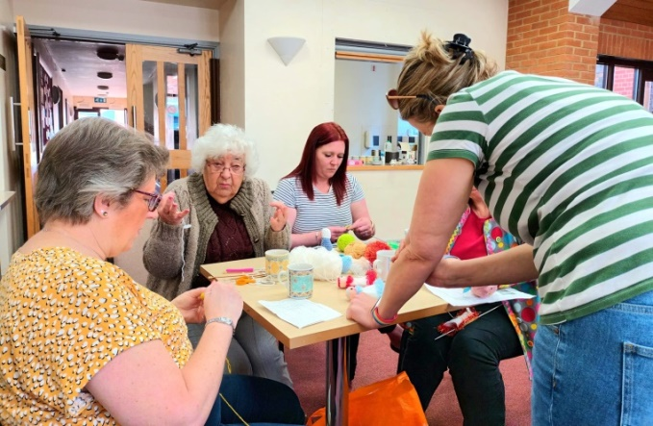
A bit of fun…what do you think Ivy is saying in the picture? Maybe something like “Mama Mia, all this wool”. Post your answers in the RCA Facebook group.

I am still trying to confirm details regarding our participation in Victoria Day, June 11th…watch this space.

If you are the point of contact for a knitter, knitting group or church could you please do your best to forward this newsletter on. I can always get you hard copies of this newsletter to you if this would help.

As always a massive thank you to ALL of you for all that you do to make this project what it is.

David Betts, 7 Redvers Buller Road, Aldershot, GU11 2LT. dabetts4x4@btinternet.com 01252 328959 or 07941 997841

