Dominic Barberi

Blessed Dominic Barberi
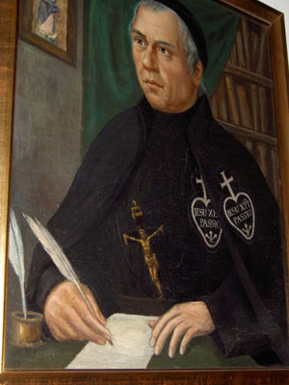
Confessor
Born | June 22, 1792, Viterbo
Died | August 27, 1849 (aged 57), Reading, Berkshire
Venerated in | Roman Catholic Church
Beatified | 27 October 1963, Rome, Italy by Pope Paul VI
Major shrine | Church of Saint Anne and Blessed Dominic, St Helens, Merseyside, England
Feast | August 27
Attributes | Passionist Habit and Sign
Patronage | England

Blessed Dominic of the Mother of God, born Dominic Barberi, a member of the Passionist Congregation and theologian, born near Viterbo, Italy, 22 June 1792; died near Reading, England, 27 August 1849. Beatified by Pope Paul VI in 1963. Also known as 'The Apostle of England'.

Birth and Early Life

His parents were peasant farmers and died while Dominic was still a small boy. There were six children, and Dominic, the youngest child, was adopted by his maternal uncle, Bartolomeo Pacelli. As a boy he was employed to take care of sheep, and when he grew older he did farm work. He was taught his letters by a Capuchin priest, and learned to read from a country lad of his own age; although he read all the books he could obtain, he had no regular education until he entered the Passionists. He was deeply religious from childhood, though experienced a period, caused by reading sensual and anti-religious texts, whereby he lost all the fervour of his childhood. During this period however he still kept up his usual devotions and his former fervour returned upon the arrival of four Passionists into the area. These Passionists had been displaced from their community in accordance with Napoleon's suppression of religious communities in the Papal States. Dominic befriend these Passionists and served daily Mass with them.

When Dominic was one of the few men of his locality not chosen for military conscription he felt it was a clear sign from God that he should enter a religious community. However, the suppression of such communities meant that Dominic would have to wait. In the meantime he discussed his vocation with the Passionists who promised him that once the Congregation was re-established they would receive him as a lay brother. During this period Dominic received an interior call which led him to believe that he was called to preach the Gospel in far off lands, later he would affirm that he had received a specific call to preach to the people of England Saint Paul of the Cross, founder of the Passionist Congregation, also had a great enthusiasm for the conversion of England. [1]

Passionist

He was received into the Congregation of the Passion in 1814 after the re-establishment of the religious orders in the Papal States. Initially Dominic was accepted as a lay brother, but once his extraordinary gifts were revealed his status was changed to that of a clerical novice, in an extraordinary break with custom.[2] During his studies Dominic's brilliance was an example to his fellow students, though he would often take steps to hide his intelligence. He was ordained priest on 1 March 1818, after which was filled with immense fervour and joy. Soon afterwards Dominic experienced a spiritual voice which told him that was to become a victim for the conversion of England.

After completing the regular course of studies, he taught philosophy and theology to the students of the congregation as lector for a period of ten years, first in Sant'Angelo and then in Rome. It was during this time that he produced his many theological and philosophical works. In the summer of 1830 he was asked to aid an English convert to Catholicism, Sir Henry Trelawney, with regard to the rubrics of the Mass. Through this meeting Dominic made the acquaintance of Ignatius Spencer and other influential English Catholics, such as Ambrose Phillips.[3] This was to be the first step in the long journey which eventually brought Blessed Dominic to England. Through his continued correspondence with these persons Dominic's hopes for England's conversion were kept alive.

He then held in Italy the offices of rector, provincial consultor, and provincial, and fulfilled the duties of these positions with ability. At the same time he constantly gave missions and retreats, always mindful of his hopes to travel and preach in England. In 1839 the Passionist General Chapter met and discussed the possibility of making a foundation in England, however the decision was never met. Finally in January 1840 negotiations were completed with regard to a Passionist foundation at Ere in Belgium, the superiors, mindful of Dominic's singular vocation to England, in spite of his age and ill health, sent Dominic to be superior of the Belgian mission.

Foundations in Belgium and England

The first Passionist Retreat in Belgium was founded at Ere near Tournai in June 1840.[4] On arrival in Belgium the local bishop was so unimpressed with Dominic's plebeian appearance that he was subjected to intense examination in moral theology before being allowed to hear confessions. Life in Belgium posed plenty of problems for the Passionists; one of the Brothers had fallen ill, the community was in abject poverty and Dominic had few words of French. Dominic's spirit rose to the occasion and soon the community was flourishing and even Dominic enjoyed good health. In September Dominic received a letter from Bishop Wisemann, the head of the English mission, inviting Dominic to make a Passionist foundation in England at Aston Hall. Dominic, with the permission of the Passionist General, visited the site in November 1840, though Ignatius Spencer warned Dominic that the situation in England would mean this would not be a favourable time to make such a foundation. Dominic set out for England once more in October 1841 where he was greeted with stares and suspicion, not only as a Catholic priest, but for the strange garb of the Passionist habit. J. Brodrick S.J. in his work on the 'Second Spring' of Catholicism in England, says of Father Dominic's arrival;

"The second spring did not begin when Newman was converted nor when the hierarchy was restored. It began on a bleak October day of 1841, when a little Italian priest in comical attire shuffled down a ship's gangway at Folkstone."[5]
After many months of waiting at Oscott College, Dominic finally secured possession of Aston Hall and so in February, 1842, after twenty-eight years of effort, he established the Passionists in England, at Aston Hall, Staffordshire. The reception of Dominic and his fellow Passionists was less than welcoming. The local Catholics feared the arrival of these newcomers would cause renewed persecutions. Dominic was also met with ridicule; his attempts to read prayers in English were met with the laughter of his congregation. The community increased in numbers and as the people of Aston grew to know Dominic they became enamoured of him and Dominic soon began to receive a steady stream of converts.[6] A centre was also set up in neighboring Stone where Dominic would say Mass and preach to the local populace. Opposition to Dominic was also present here where on his journeys to the Mass centre local youths would throw rocks as Dominic, though two youths took to the decision to become Catholics when they were greatly edified to see Dominic kiss each rock that hit him and place it in his pocket. During many of these frequent attacks Dominic was lucky to escape death.

Local Protestant ministers often held anti - Catholic lectures and sermons toward the people away from Blessed Dominic and the Catholics. Wilson records how one of these ministers followed Dominic along a street shouting out various arguments against transsubstantiation, Dominic was silent, but as the man was about to turn off, Dominic retorted;

"Jesus Christ said over the consecrated elements, "This is my body" you say "No. It is not his body!" Who then am I to believe? I prefer to believe Jesus Christ."[7]
Converts increased at Stone, so much so that a new church had to be built. It was at Aston however that on 10 June 1844 the first Corpus Christi procession was held in the British Isles, an event which attracted thousands of Catholics and Protestants alike.[8] Dominic then began to visit other parishes and religious communities in order to preach, such 'missions' as they are called caused Dominic's reputation to become widely known in England. These missions frequently took place in the industrial cities of northern England, such as Manchester, Liverpool and Birmingham.

Newman's conversion
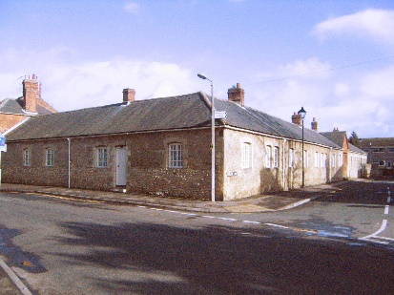
The College, Littlemore where Dominic received Newman into the Church

Whilst in Italy and latterly in Belgium, Dominic had always kept up a keen interest in the Oxford Movement. In 1841 a letter by John Dobree Dalgairns appeared in L'Univers explaining the position of the Anglican High Church party. Dominic decided to respond to this letter which he believed represented the views of the entire faculty of Oxford University (Dalgairns was an undergraduate when he had written the letter). In his 'Letter to University Professors at Oxford' Dominic describes his long hopes for the conversion of England and his belief that the men of Oxford would be instrumental in such a conversion. The letter, through the help of Ignatius Spencer eventually ended up in the hands of Dalgairns who was residing with John Henry Newman at Littlemore. Dominic repudiated the Anglican claim that the 39 Articles could be interpreted in a Catholic light. In their continued correspondence Dalgairns and Dominic debated the Catholic position and Dalgairns requested copies of the Passionist Rule and Dominic's 'The Lament of England'. Eventually Dalgairns was received into the Catholic Church by Dominic at Aston in September 1845.[9]

In October of that same year Dominic visited Littlemore where Newman made his confession to him.[10] Newman relates in his Apologia of how Dominic arrived soaked from the rain and as he was drying himself by the fire Newman knelt and asked to be received into the Catholic Church.[11] This event is marked by a sculpture in the Catholic Church of Blessed Dominic Barberi at Littlemore. Two of Newman's companions at Littlemore were also received and Dominic celebrated Mass for them the following morning. Newman and Dominic always afterward followed each other's careers.

Further Work and Death
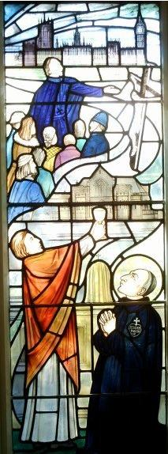
Window from Blessed Dominic's Shrine
The community at Aston had reached fifteen religious and in 1846 a new foundation was made at Woodchester in Gloucestershire and in 1848 the Passionists arrived in London. In the last years of his life Dominic engaged in negotiations for the foundation of St. Anne's Retreat, Sutton where today he lies buried. In 1847 The Honorable George Spencer, Dominic's long standing friend was received into the Congregation of the Passion [12] Throughout this time Dominic fulfilled his duties in preaching missions and heading the English and Belgian foundations. The number of his converts during this time is immeasurable. One story told of Dominic during this time that expresses his joyful sense of humour is that once he was visiting a convent of nuns who were instructing many converts, some of them male. Dominic was informed that some of the sisters were worried about teaching men, Dominic retorted:

"Have no fear, Sisters. You are all too old and too ugly."[13]
The Sisters appreciated Dominic's humour so much that they recorded the incident in their archives. All such work inevitably took its toll upon Father Dominic's health and from 1847 he insisted that his life had nearly run its course. He had preached numerous retreats, both alone and with Father Ignatius, both in England and Ireland. On 27 August 1849 Dominic was travelling from London to Woodchester when, at Pangbourne, he suffered a heart attack. On being taken to the Railway Tavern at Reading (later the Duke of Edinburgh Hotel, now demolished) he died after being given absolution. He was buried in St Anne's Church, St Helens, Merseyside, which is also the shrine of the Servants of God Elizabeth Prout and Ignatius Spencer.

Beatification and Legacy

Dominic was beatified by Pope Paul VI in 1963, during the Second Vatican Council. In his homily at Blessed Dominic's beatification Pope Paul said of Dominic:

"he was a man of both prayer and action: we know that Father Dominic was great master of asceticism, indefatigable preacher, apostle and expert apologist of the contemporary thought of his time, aware also then of ancient and new ideas and dangerous errors."[14]
Later popes also admired Dominic, on his visit to England in 1982 Pope John Paul II described Blessed Dominic as:
"One example of the countless other priests who continue to serve as models of holiness for the clergy of today."[15]
Dominic is best remembered for his part in Newman's conversion, but is also commemorated for his exhausting work in the efforts to return England to the Catholic faith in the nineteenth century. Such was Dominic's work in England that Cardinal Bourne said of him in 1926:
"Of all the preachers of the divine word who have worked for the salvation of souls in England there is no one to whom we are more indebted than the Servant of God, Dominic Barberi. I should consider myself happy if I had the power to dedicate this whole diocese to his care and protection and be allowed to honour him as our Patron and Protector in England."[16]
In his short years in England Dominic established three churches, several chapels and preached innumerable missions and received hundreds of converts, not only Newman, but others such as Spencer and Dalgairns. Dominic now lies at rest with Father Ignatius Spencer and Elizabeth Prout (whom Dominic had received into the Church and who founded the Sisters of the Cross and Passion) in the Shrine Church of Saint Anne and Blessed Dominic in Sutton, St Helens.

Literary Works
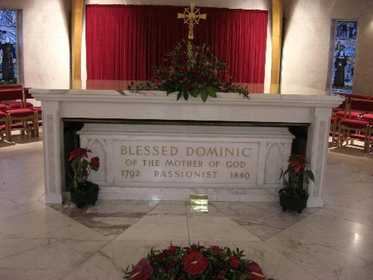
The shrine of Blessed Dominic Barberi

Among Father Dominic's works are: courses of philosophy and moral theology; a volume on the Passion of Our Lord; a work for nuns on the Sorrows of the Blessed Virgin, "Divina Paraninfa"; a refutation of de Lamennais; three series of sermons; various controversial and ascetical works. In 1841 he addressed a Latin letter to the professors of Oxford in which he answered the objections and explained the difficulties of Anglicans.[17] One of Blessed Dominic's most famed works was his 'Lamentation of England'[18] whereby he used the words of the Prophet Jeremiah to express the lamentations of English Catholics.

References
- ↑ Wilson C.P., Alfred (1967). Blessed Dominic Barberi, Supernaturalised Briton. page 36
- ↑ Wilson C.P., Alfred (1963). Blessed Dominic Barberi, Apostle of Christian Unity. page 5
- ↑ Wilson C.P., Alfred (1967). Blessed Dominic Barberi, Supernaturalised Briton. page 123
- ↑ Wilson C.P., Alfred (1967). Blessed Dominic Barberi, Supernaturalised Briton. page 210
- ↑ As quoted in: Wilson C.P., Alfred (1967). Blessed Dominic Barberi, Supernaturalised Briton. page 233
- ↑ Wilson C.P., Alfred (1963). Blessed Dominic Barberi, Apostle of Christian Unity. page 10
- ↑ Wilson C.P., Alfred (1967). Blessed Dominic Barberi, Supernaturalised Briton. page 256
- ↑ Wilson C.P., Alfred (1967). Blessed Dominic Barberi, Supernaturalised Briton. page 259
- ↑ Wilson C.P., Alfred (1967). Blessed Dominic Barberi, Supernaturalised Briton. page 301
- ↑ Wilson C.P., Alfred (1963). Blessed Dominic Barberi, Apostle of Christian Unity. page 11
- ↑ Newman, J. H. (1864). Apolgia Pro Vita Sua. page 325
- ↑ Wilson C.P., Alfred (1967). Blessed Dominic Barberi, Supernaturalised Briton. page 339
- ↑ Wilson C.P., Alfred (1967). Blessed Dominic Barberi, Supernaturalised Briton. page 348
- ↑ Discourse of Pope Paul VI on Blessed Dominic of the Mother of God, Passionist, on the occasion of his solemn beatification. Dated Sunday, 27 October 1963
- ↑ Pastoral visit to Great Britain: Homily of John Paul II. Manchester, 31 May 1982.
- ↑ Wilson C.P., Alfred (1963). Blessed Dominic Barberi, Apostle of Christian Unity. page 1.
- ↑ Letter to the Professors of the University of Oxford. Dated May 5th, 1841.
- ↑ The Lamentation of England. Published in England in 1831.

