“Rushmoor Christmas Angels” January 2021 Newsletter.
Hello everyone…..First of all a Happy New year to you all, we hope that your Christmas was a good one albeit probably very different.

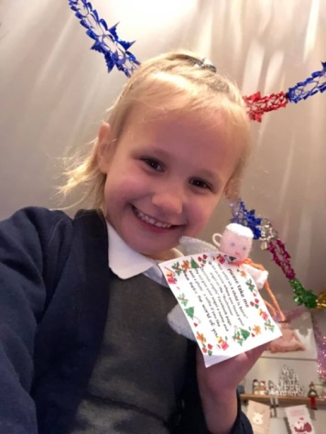
Secondly a massive thank you for all your efforts to make “Rushmoor Christmas angels” 2020 the success that it was. Thank you to all our knitters, thank you to all those who prepared and attached the labels to our angels and thank you to those who distributed the angels around our community and once again found some very imaginative places to hide them

Thirdly, we would also like to say “welcome” to all those who have joined our team since the last newsletter was sent out. Hopefully it won’t be too long before we can all gather together again in person so we can meet you all and welcome you properly.

There were so many pictures posted of our angels on our Facebook page that it was hard to choose which ones to include here. However, I think the 3 pictures in this newsletter sum up nicely the joy that our angels have brought this Christmas.
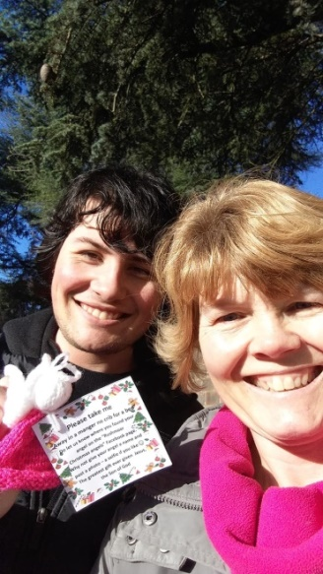
It is often the case that some of our angels are not found until spring time, when people start tending their gardens again so do keep a watch on the Facebook page for the “stragglers” to appear.

At the time of writing we have just under 500 people in the “Rushmoor Christmas Angels knitters” Facebook group. We know that not everyone in this group is a knitter but if each person did knit just 10 angels we will have at last 5,000 angels ready to fly during Christmas 2021……and we know that some of our knitters have already started knitting for this coming Christmas.

If you are on social media please do consider joining the “Rushmoor Christmas Angels Knitters” group. This is where information is uploaded in between the publication of monthly newsletters.
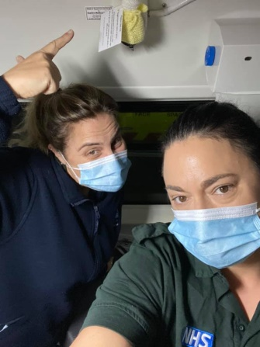
At the moment Rushmoor is in Tier 4 which means that we are not going to be able to meet up for a knitting session for the foreseeable future but we remain hopeful that it will not be too long before we can do so. As soon as we are able we will organise a Saturday morning when we can all meet up together again.

If you are the point of contact for a knitter/knitting group or church could you please do your best to forward this newsletter on to members of your team and if possible print off and display this newsletter on your church noticeboard. This is especially important if some of your team are not on social media. This newsletter is often their only means of finding out current information about the project. I can always get you hard copies of this newsletter if this would help.

A knitters’ blessing – “May your stiches never drop and may your wool stash be plentiful”

David Betts, 7 Redvers Buller Road, Aldershot, GU11 2LT. dabetts4x4@btinternet.com 01252 328959 or 07941 997841 or 07747 216735

