“Rushmoor Christmas Angels” June 2022 Newsletter.

Hello everyone.
It was lovely to see you all that the last “knitting party” a few days ago……did you know however that the largest number of people to be knitting together in one room is a staggering 3,083. We still have a long way to go to beat this. This record was achieved by the Women’s Institute (naturally) in The Royal Albert Hall in 2012.

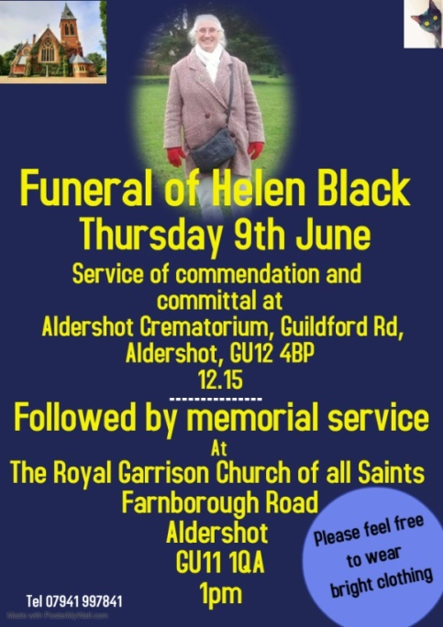
Good news…….It was a (very) long process but we have finally managed to get things sorted for our involvement in Aldershot’s Victoria Day 2022. This year we are going to be located just inside the main entrance to the Wellington Centre (just down from McDonalds). I am hoping the Wellington centre will provide us with a table and along with the plastic sign we had made up a few years ago I think we should have a good visible presence (we will also be dry if it decides to rain. All we need to bring along on the day is our knitting (obviously) and some fold up chairs to sit on. If you want to display some of your already knitted angels please do. The second Saturday in June is always “National knitting outside day”. Although we are not technically “outside” I think the Wellington centre counts
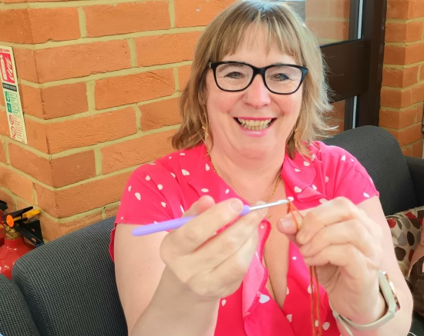
Victoria Day runs from 10-4pm but please do come along when you can and go when you must.

We now have details of Helen’s funeral. You would all be welcome to attend both the service of Commendation and Committal at Aldershot crematorium at 12.15 as well as the thanksgiving service at The Royal Garrison Church of all Saints at 1pm. There will be refreshments served after the service to which you are welcome to stay for. All the details/postcodes etc are here

Someone once said that you know when you are a knitting addict when you take a break from a big knitting project and relax by working on another knitting project. I wouldn’t be surprised if this resonates with a few of you

As much as I wanted a gathering of knitters to be called a “spool” or a “needle” it is actually a “skein”. With this in mind our next “skein” will probably be on Saturday June 25th
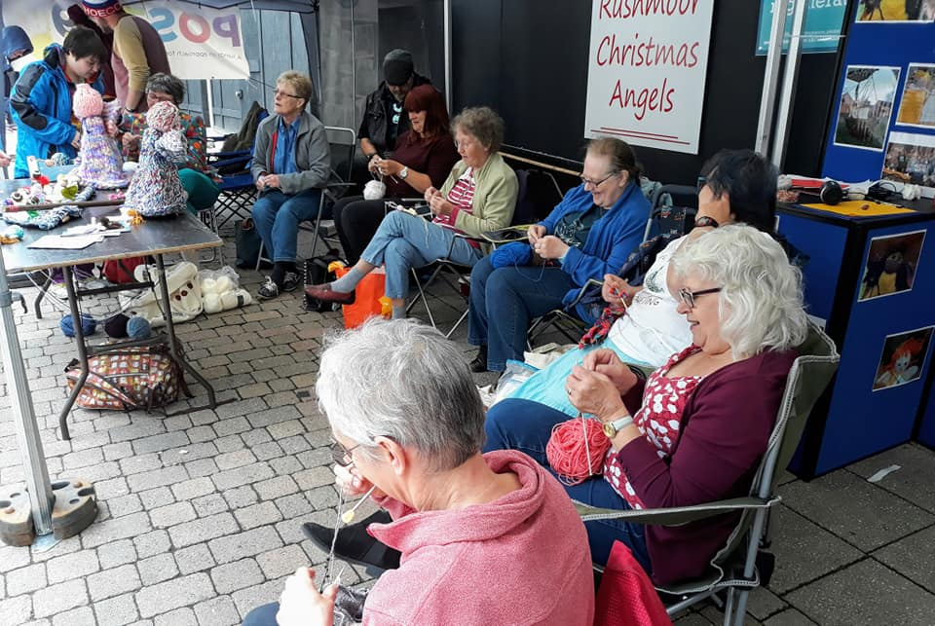
If you are the point of contact for a knitter, knitting group or church could you please do your best to forward this newsletter on. I can always get you hard copies of this newsletter to you if this would help.

As always a massive thank you to ALL of you for all that you do to make this project what it is.

David Betts, 7 Redvers Buller Road, Aldershot, GU11 2LT. dabetts4x4@btinternet.com 01252 328959 or 07941 997841

