“Rushmoor Christmas Angels” November Newsletter.

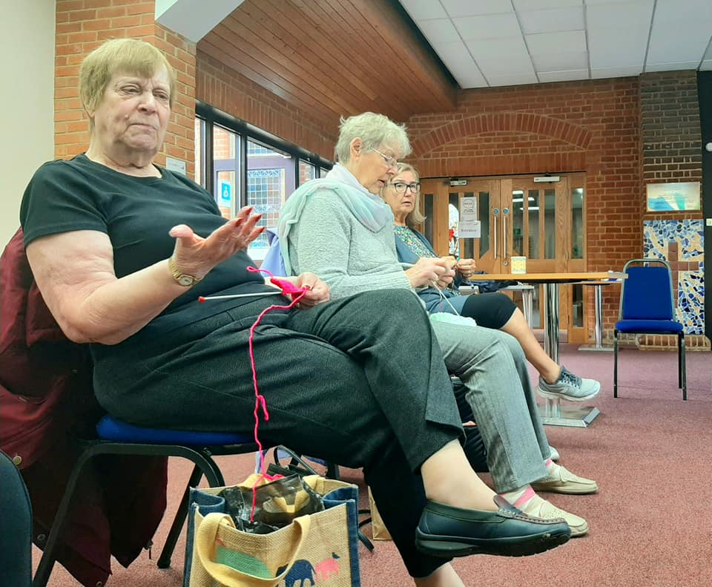
Hello everyone,
It was lovely to see everyone at the Knitting party a few weeks ago. Our next “knitting party” will be on Tuesday 23rd November at North Camp Methodist Church from 7pm – 9pm. Hopefully, those of you who find Saturdays difficult will be able to join us on this evening.

We now have 12000 labels for our angels. If you need labels for the angels you have knitted then do come along on the 23rd and pick some up.

We also have almost 300 angels that need to have labels attached. So if you are one of those lovely people who kindly attached labels and then distribute the angels please do come along on the 23rd as well.

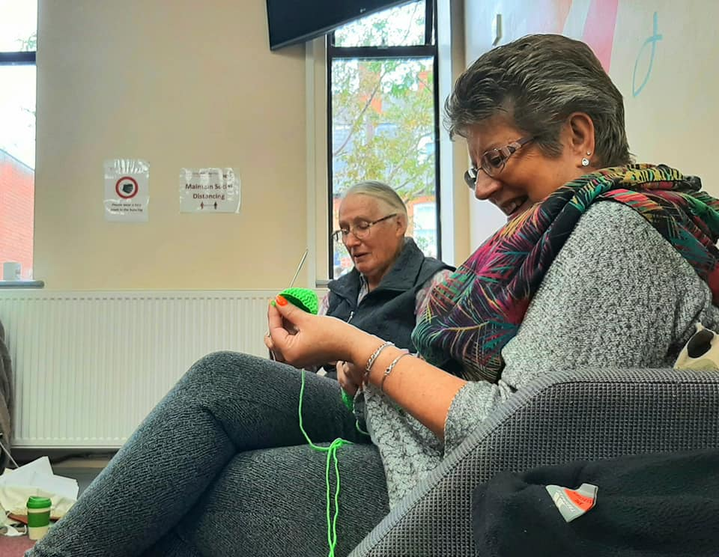
Just a reminder that we decided a few years ago that we were no longer going to laminate our labels. It just didn’t seem right to put over 2000 “one use” sheets of plastic around our community especially as most of our angels (if placed in the evening) are usually found quite quickly the next morning. We did an experiment a year or so ago by hanging a label on a clothes line for a day or so and found that they were quite weather resistant.

If you are able to label and distribute your own angels around your local community that is great. Obviously you are more likely to be aware of those who would appreciate finding one of our angels on their doorsteps. If however you feel you are not able to distribute your angels please bring them along to on the 23rd or to the “Dedication service” on December 2nd (see below) and someone will distribute your angels for you. Any other questions make contact via the “RCA Knitters” group and someone will help you out.
The plan is still to meet “in person” for our usual “Angel dedication service”. This year it will be held at North Camp Methodist Church on Thursday 2nd December at 7pm. For your information “Angel week” this year will begin Monday 6th December. Although we still call it angel “week” we have found that it is almost impossible to place all our angels around our community in 7 days. The project now in effect runs all the way up to Christmas Day so please do not feel pressured to distribute your angels in the first seven days of December.
If you are the point of contact for a knitter, knitting group or church could you please do your best to forward this newsletter on to members of your team. This is especially important if some of your team are not on social media/email etc. This newsletter is often their only means of finding out information about our project. I can always get you hard copies of this newsletter if this would help.

Once again a massive thank you to all of you for all that you do to make this project what it is.

David Betts, 7 Redvers Buller Road, Aldershot, GU11 2LT. dabetts4x4@btinternet.com 01252 328959 or 07941 997841

