“Rushmoor Christmas Angels” September 2020 Newsletter.

Hello everyone, we hope that you all had a good summer.
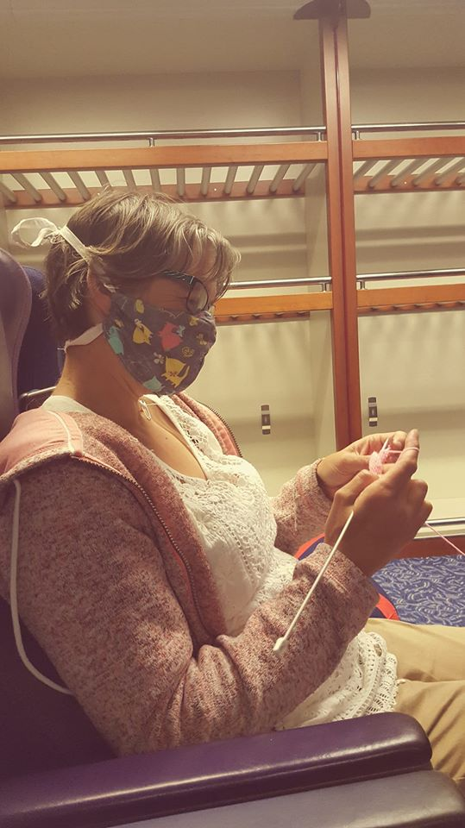
Welcome to those knitters who have joined us since the last newsletter was distributed. It is great to have you on board.

As you can see from the two pictures below Covid19 did not disrupt your knitting over the holiday season too much
We have 3 months until Rushmoor Christmas Angels 2020 launches. We are very much hoping that our knitted angels will bring some smiles and hope to many families at the end of a year most of us would rather forget.

Thank you to those who have messaged letting us know how many angels you have knitted so far. As we have mentioned previously it is always useful to have these figures as we begin to prepare our press releases.

I have a couple of laundry bags full of donated wool, some of it brand new and in its original packaging. I will be at North Camp Methodist Church in the main hall on Saturday 19th September from 10am if you want to swing by and pick some up (enter through the doors in the carpark). I will also have some of our new labels available. Please note that this will just be a socially distanced “drop off and pick up session” and the usual Covid19 guidelines will need to be adhered to (track and trace, hand sanitiser, face masks etc). However, if you can come along even if it is just for 15mins it will be good to see you.

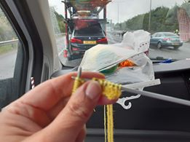
You may have seen we are introducing 2 new designs for our labels this year and we are hoping that we have “sponsorship” to get these produced in colour. If you have already started using labels from previous years please do not worry. Remember that this year to cut down on the amount of plastic we use we are not going to be laminating the labels so attaching labels to our angels should be a pretty straight forward task. We have discovered that most people find their angels within 12 hours of them being placed so unless an angel is unfortunate enough to be caught in a “down pour” the labels are perfectly readable for quite some time. Labels can also be found under the files section of the “Rushmoor Christmas Knitters” Facebook group.

We are still planning to have our “Rushmoor Christmas Angels” dedication service on Thursday 3rd December (this might have to take place “virtually” via Zoom and then we will post the service on our Facebook page). Watch this space.

As you can see we are doing all that can be done to make sure “Rushmoor Christmas Angels 2020” is as successful as it has been in the previous 6 years.

If you are the point of contact for a knitting group or church could you please pass this newsletter onto members of your team and if possible display this on your church noticeboard

David Betts, 7 Redvers Buller Road, Aldershot, GU11 2LT. dabetts4x4@btinternet.com 01252 328959 or 07941 997841 or 07747 216735

